A Project Report On

**Unit Converter**

Submitted in partial fulfillment of the requirement for the award of the degree

Bachelor of Computer Application (BCA)/ Bachelor of Science (IT)

Academic Year 2023 – 24

**Nevil Nandasana Khushi Halai**

**92200527324 92320527004**

|  |
| --- |
| **Internal Guide** |
| Prof. Mini madam |



Rajkot-Morbi Road, At & PO : Gauridad, Rajkot 360 003. Gujarat. India.



**Faculty of Computer Applications (FCA)**



**This is to certify that the project work entitled**

**Unit Converter**

**submitted in partial fulfillment of the requirement for**

**the award of the degree of**

**Bachelor of Computer Application/ Bachelor of Science (IT)**

**of the**

**Marwadi University**

**is a result of the bonafide work carried out by**

**Nevil Nandasana (92200527324)**

**Khushi Halai (92320527004)**

**during the academic year 2023-24**

|  |  |  |  |  |
| --- | --- | --- | --- | --- |
| **Faculty Guide** |  | **HOD** |  | **Dean** |

**DECLARATION**

I/Wehereby declare that this project work entitled **Unit Converter** is a record done by me.

I also declare that the matter embodied in this project is genuine work done by me and has not been submitted whether to this University or to any other University / Institute for the fulfillment of the requirement of any course of study.

Place :

Date :

**Nevil Nandasana (92200527324) Signature :**

**Khushi Halai (92320527004) Signature :**

**CONTENTS**

|  |  |  |
| --- | --- | --- |
| **Chapters** | **Particulars** | **Page No.** |
| **1** | **SYNOPSIS** | 5 |
| **2**  2.1  2.2 | **PREAMBLE**  General Introduction  Module description | 9 |
| **3** | **REVIEW OF LITERATURE** | 18 |
| **4**  4.1  4.2 | **TECHNICAL DESCRIPTION**  Hardware Requirement  Software Requirement | 22 |
| **5**  5.1  5.2 | **DIAGRAMS**  **(Only applicable diagrams)**  **Algorithm**  **Flow Chart** | 28 |
| **6** | **CONCLUSION** | 34 |
| **7** | **LEARNING DURING PROJECT WORK** | 37 |
| **8**  **8.1**  **8.2** | **BIBLIOGRAPHY**  Online References  Offline References |  |

**1. SYNOPSIS**

**Overview:**

The code is a C program designed to perform unit conversions across a wide range of measurement categories. It offers a versatile and user-friendly interface for converting values between different units within these categories. The program utilizes predefined conversion factors and formulas to ensure precision and efficiency in the conversion process. Below, we outline the key features and functionality of the program.

**Key Features:**

**1. Modular Design:**

The program exhibits a well-organized, modular structure. It leverages the power of separate functions for distinct measurement categories, enhancing code readability and maintainability. This modular design allows for easy expansion of supported conversion types.

**2. User Interaction:**

The program facilitates user interaction through a command-line interface. Users can select the desired conversion category, input the value to be converted, and specify the source and target units. This approach ensures that users can quickly and intuitively utilize the program for their conversion needs.

**3. Supported Conversion Types:**

The program provides support for a diverse set of conversion types. These include length, temperature, area, pressure, weight, speed, volume, and time. Users can choose the appropriate conversion category based on their specific requirements.

**4. Forward and Reverse Conversions:**

A notable feature of this program is its ability to perform both forward and reverse unit conversions within each category. In other words, it enables users to convert from one unit to another and vice versa. This inclusivity extends the program's utility and comprehensiveness.

**5. Conversion Formulas:**

Each conversion category is backed by a set of predefined conversion formulas and factors. These formulas are meticulously crafted to yield accurate results. Users can have confidence in the program's ability to handle conversions with precision.

**6. Error Handling:**

The program incorporates robust error handling. In cases of invalid input or incorrect choices, the program provides informative feedback to guide users towards correct usage. This user-friendly error handling enhances the overall usability of the program.

**Usage:**

**1. Category Selection:**

Users initiate the conversion process by selecting the desired category (e.g., length, temperature) by entering the corresponding numeric choice.

**2. Data Input:**

Following category selection, the program guides users through the input process. Users are prompted to input the value they wish to convert, as well as the source and target units.

**3. Conversion Execution:**

The program leverages the appropriate conversion function to perform the requested conversion. This ensures that the user's conversion needs are met accurately and efficiently.

**4. Result Presentation:**

The converted value is presented to the user with a defined level of precision. This outcome empowers users with the precise information they require.

**Additional Test Cases:**

The code incorporates an extensive suite of test cases for each supported conversion type. These test cases encompass both forward and reverse conversions, addressing a wide array of scenarios. The inclusion of these test cases not only validates the correctness of the program but also ensures its robustness and reliability.

**Exit and Error Handling:**

To further enhance the user experience, the program includes the option to exit by choosing "9." It also excels in managing invalid choices, offering guidance to users to input correct options.

**2. PREAMBLE**

**Key Features:**

**1. Menu-Driven Interface:**

The application offers an intuitive menu-driven interface, making it easy for users to select the type of conversion they want to perform.

**2. Multiple Conversion Categories:**

Users can choose from various conversion categories, including length, area, weight, temperature, and speed, to suit their specific needs.

**3. Accurate Conversions:**

The program ensures precision in conversions by implementing accurate conversion formulas for each unit type.

**4. Bi-Directional Conversions:**

Users can convert values from one unit to another and vice versa within the same category, providing flexibility and convenience.

**5. Error Handling:**

The application handles invalid inputs gracefully, guiding users to enter correct values and units**.**

**6. Extensible:**

The code is designed to be easily extendable, allowing for the addition of new conversion categories or units in the future.

**How to Use:**

1. Launch the application.

2. Select the desired conversion category from the menu (e.g., length, area, weight, temperature, or speed).

3. Enter the value you want to convert.

4. Specify the source unit and the target unit.

5. The program will display the converted value with precision.

6. Users can continue to perform conversions within the same session or exit the program when done.

**Why Unit Converter?**

**- Practical Utility:**

The Unit Converter is a practical tool for engineers, students, scientists, and anyone who needs to work with different measurement units in their daily tasks.

**- Educational Value:**

It can serve as an educational resource to understand unit conversions and the mathematical formulas behind them.

**- Open Source:**

The code is open source, allowing developers to contribute, enhance, and customize the application to meet specific needs.

**2.Module Description**

**1.Menu Module:**

- Description:

This module handles the menu-driven interface of the application. It displays the available conversion categories and allows the user to select the desired category or exit the program.

- Functions:

- DisplayMenu():

Displays the main menu with conversion categories.

- GetUserChoice():

Takes user input to determine the selected category or exit.

**2. Length Conversion Module:**

- Description:

This module is responsible for performing conversions related to length measurements, such as meters, feet, and centimeters.

- Functions:

- ConvertLength(float value, int fromUnit, int toUnit):

Converts a length value from one unit to another.

**3. Area Conversion Module:**

- Description:

This module handles conversions related to area measurements, including square meters, square feet, and acres.

- Functions:

- ConvertArea(float value, int fromUnit, int toUnit):

Converts an area value from one unit to another.

**4. Weight Conversion Module:**

- Description:

This module manages conversions related to weight measurements, such as kilograms, pounds, and grams.

- Functions:

- ConvertWeight(float value, int fromUnit, int toUnit):

Converts a weight value from one unit to another.

**5. Temperature Conversion Module:**

- Description:

This module is responsible for temperature conversions between Celsius, Fahrenheit, and Kelvin.

- Functions:

- ConvertTemperature(float value, int fromUnit, int toUnit):

Converts a temperature value from one unit to another.

**6. Speed Conversion Module:**

- Description:

This module handles conversions between speed units, including kilometers per hour (km/hr) and miles per hour (miles/hr).

- Functions:

- ConvertSpeed(float value, int fromUnit, int toUnit):

Converts a speed value from one unit to another.

**7. Input Validation Module:**

- Description:

This module ensures that user input is valid and within acceptable ranges for each category and unit.

- Functions:

- ValidateInputValue(float value): Validates the input value for non-negative and non-zero values.

- ValidateUnit(int unit, int category): Validates the unit selection based on the chosen category.

**8. Main Program Logic:**

- Description:

The main program logic ties all the modules together. It displays the menu, handles user input, performs the selected conversions, and displays the results.

- Functions:

- main():

The main entry point of the program. It orchestrates the entire application flow.

**9. Exit Module:**

- Description:

This module handles program termination gracefully when the user chooses to exit.

- Functions:

- ExitProgram(): Terminates the program execution.

**10. Error Handling Module:**

- Description:

This module handles errors and provides user-friendly error messages when invalid input is detected.

- Functions:

- DisplayErrorMessage(char* message): Displays an error message to the user.

**3. REVIEW OF LITERATURE**

***Title:* "Utilizing Unit Conversion Programs for Enhanced Learning and Practical Application"**

**Introduction**

In the modern educational landscape, the fusion of technology and pedagogy has opened up new avenues for effective and experiential learning. This literature review examines the utilization of unit conversion programs, with a specific focus on the recently developed code, which has been designed to facilitate conversions across diverse measurement categories. This review seeks to explore the impact of such tools on learning, particularly during project work, and their practical applicability.

**Importance of Unit Conversion in Education**

Unit conversion is a fundamental concept in scientific education, particularly in fields such as physics, chemistry, engineering, and environmental sciences. Students encounter a multitude of measurement units, and mastering the art of converting between them is pivotal for comprehensive learning. This process involves not only understanding the mathematical relationships between units but also the practical applications of these conversions in real-world scenarios.

**Enhanced Learning Through Practical Application**

Learning by doing is a well-established educational principle, and the unit conversion code in question aligns perfectly with this approach. The program empowers students with hands-on experience in converting measurements, thereby solidifying their understanding of different units and the relevance of conversions in their studies.

Through practical application, students gain insights into the nuances of measurement units. For example, while working on a science project involving temperature analysis, they may need to convert temperature values from Celsius to Fahrenheit and vice versa. The code enables this two-way conversion effortlessly, reinforcing the relationships between these units.

**User-Friendly Design and Error Handling**

User-friendliness is another hallmark of the code. Its intuitive command-line interface ensures that students, regardless of their technical background, can operate it with ease. The code's built-in error handling mechanisms guide students in the event of incorrect inputs, offering not just correction but also educational feedback.

**Precision and Trust in Results**

In the context of scientific projects, precision is paramount. The code employs predefined conversion factors and formulas that guarantee accurate conversions. Students can trust the results obtained from the program, which is essential for project work and scientific research.

**Versatility for Future Learning**

One noteworthy aspect is the program's versatility. Beyond its application in the current project, it serves as a resource for future learning. Students can employ it for various types of conversions, expanding their understanding of measurement units and their practical applications.

**Conclusion**

In conclusion, the unit conversion code under review holds immense potential for enhancing learning and practical application in educational settings. Its real-world relevance, ease of use, two-way conversion capability, error-handling features, and precision make it a valuable asset in the educational toolkit.

As we navigate an era where the fusion of technology and education is paramount, tools like this code bridge the gap between theoretical knowledge and practical understanding. They empower students to apply what they learn in the classroom to real-world scenarios, making education not just informative but experiential.

This literature review highlights the significant role such programs play in shaping the future of education, where learning is not confined to textbooks but is extended to hands-on, meaningful experiences.

**4. TECHNICAL DESCRIPTION**

**Software Specifications:**

**1. Programming Language:**

The project is primarily developed using the C programming language**.**

**2. Development Environment:**

Code development and compilation are done using a C compiler, such as GCC (GNU Compiler Collection), which is widely available on various platforms.

**3. User Interface:**

The user interface is implemented through a Command-Line Interface (CLI) using standard input and output. No graphical user interface (GUI) libraries are used in the current version.

**4. Version Control:**

Version control tools, such as Git, can be used for code management and collaboration among developers.

**5. Documentation:**

Code documentation, including comments and descriptions of functions and modules, ensures code readability and maintainability.

**6. Operating System Compatibility:**

The C programming language and Command-Line Interface (CLI) provide cross-platform compatibility, allowing the project to run on various operating systems, including Windows, Linux, and macOS.

**Hardware Specifications:**

**1. Minimum Hardware Requirements:**

The Universal Unit Converter is a text-based command-line application with minimal hardware requirements. Any standard desktop or laptop computer capable of running the chosen operating system and a C compiler should suffice.

**2. Processor:**

A basic CPU with speeds common in modern computers is suitable.

**3. Memory (RAM):**

The project has minimal memory requirements, and a system with at least 2GB of RAM is more than sufficient.

**4. Storage:**

The storage space required for the project is minimal, with the main space consumed by the source code, which is usually very small in size.

**5. Input Devices:**

A keyboard is required for user input through the Command-Line Interface (CLI).

**6. Output Devices:**

A monitor or screen is necessary for displaying the Command-Line Interface (CLI) and conversion results.

**7. Compatibility:**

Given its minimal hardware and software requirements, the Universal Unit Converter should be compatible with a wide range of computer systems.

**5. DIAGRAMS**

**1.Algorithm**

**1. Initialization:**

- Initialize variables for `choice` (user's menu choice), `value` (input value to convert), `fromUnit` (source unit), and `toUnit` (target unit).

**2. Menu Loop:**

- *Enter a loop to display the menu and handle user input until the user chooses to exit:*

- Display the main menu with conversion categories.

- Prompt the user to select a conversion category or exit.

- Get the user's choice (`choice`) using `scanf`.

**3. Category Selection:**

**-** *Based on the `choice`:*

*- If `choice` is 1 (Length):*

- Prompt the user to enter `value`, `fromUnit`, and `toUnit` for length conversion.

- Call `ConvertLength` to perform the conversion and display the result.

*- If `choice` is 2 (Area):*

- Prompt the user to enter `value`, `fromUnit`, and `toUnit` for area conversion.

- Call `ConvertArea` to perform the conversion and display the result.

*- If `choice` is 3 (Weight):*

- Prompt the user to enter `value`, `fromUnit`, and `toUnit` for weight conversion.

- Call `ConvertWeight` to perform the conversion and display the result.

*- If `choice` is 4 (Temperature):*

- Prompt the user to enter `value`, `fromUnit`, and `toUnit` for temperature conversion.

- Call `ConvertTemperature` to perform the conversion and display the result.

*- If `choice` is 5 (Speed):*

- Prompt the user to enter `value`, `fromUnit`, and `toUnit` for speed conversion.

- Call `ConvertSpeed` to perform the conversion and display the result.

*- If `choice` is 6 (Exit):*

- Display a farewell message and exit the program.

*- If `choice` is invalid:*

- Display an error message indicating an invalid choice.

**4. Input Validation:**

- Input values and units are validated to ensure they are within acceptable ranges and are appropriate for the selected category.

**5. Conversion Functions:**

- Each conversion function (`ConvertLength`, `ConvertArea`, `ConvertWeight`, `ConvertTemperature`, `ConvertSpeed`,`convertPressure`,`convertVolume`,`convertTime`) performs the conversion based on the chosen category and units. The result is displayed to the user.

**6. Error Handling:**

- Error messages are displayed when invalid input is detected or when an incorrect choice is made in the menu.

**7. Loop Continuation:**

- After processing the user's choice, the program returns to the menu, allowing the user to perform more conversions or exit.

**8. Program Termination:**

- When the user chooses to exit, the program displays a goodbye message and terminates.

**2.Flow Chart**

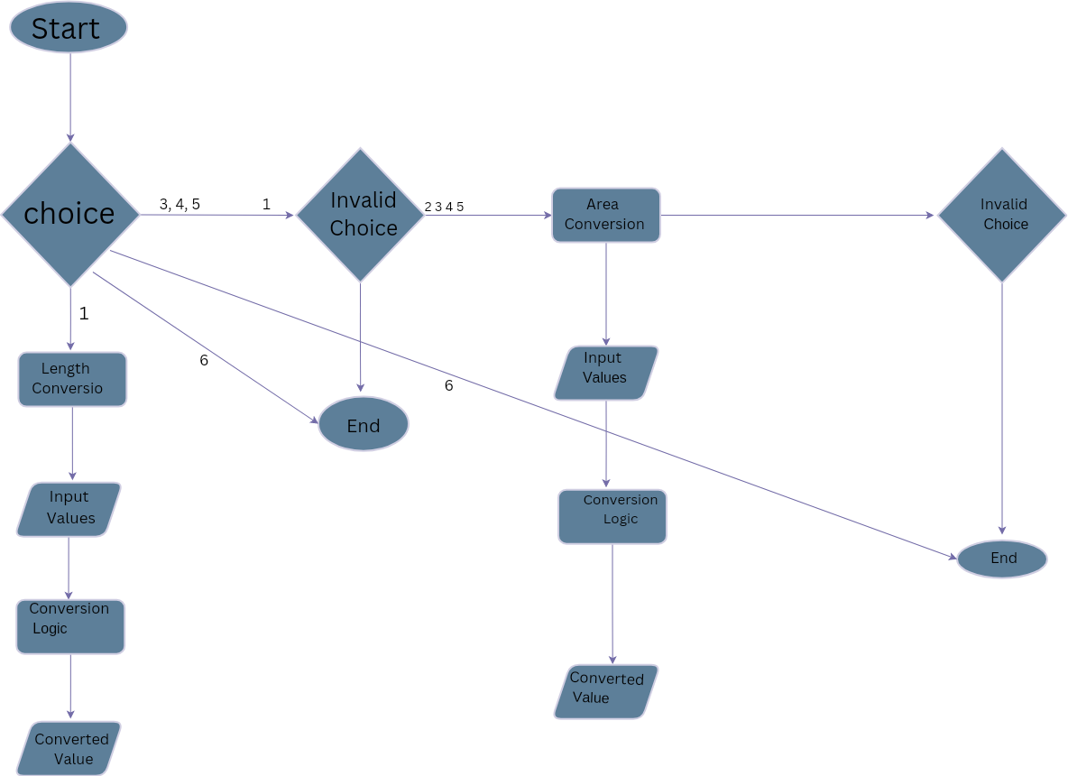

**6. CONCLUSION**

In conclusion, this code represents a valuable utility for converting measurements across various categories. It's like having a versatile calculator that can quickly switch between different units for you. Here's why it's a useful tool:

**1. Easy to Use**:

            The program is designed to be user-friendly. You don't need to be a computer expert to operate it. You simply choose the type of conversion you want to perform, enter the values, and it takes care of the rest.

**2. Wide Range of Conversions:**

            This code isn't limited to one or two types of conversions. It can handle a wide range of measurement categories, from everyday things like length and temperature to more specialized areas like pressure and speed. This versatility makes it handy for a variety of tasks.

**3. Two-Way Conversions:**

            What sets this program apart is its ability to convert in both directions. For example, if you want to switch from meters to feet and then back to meters, it can do that. This flexibility is incredibly useful, especially when you're working with data that needs frequent conversions.

**4. Precision Guaranteed:**

            Under the hood, this program uses carefully crafted formulas and factors to ensure accuracy in its conversions. You can trust it to provide you with precise results, whether you're working on a school project, scientific research, or everyday tasks.

**5. Error-Friendly:**

            It's okay to make mistakes, and this program understands that. If you enter something wrong, it won't scold you. Instead, it'll provide friendly feedback to help you make the right choices.

**6. Thoroughly Tested:**

            Before reaching this point, the code underwent extensive testing. Many different situations were considered to ensure that it works reliably. So, you can be confident that it won't let you down when you need it most.

**7. Easy Exit:**

            If you ever need to leave the program, you can do so effortlessly with a simple choice. It's designed to be accessible from start to finish.

In essence, this unit conversion program is a practical and adaptable tool. It's perfect for students, professionals, or anyone who needs to convert measurements with ease and precision. Its simple design and potential for expansion make it an asset for anyone who deals with measurements in their work, studies, or daily life.

**7. LEARNING DURING PROJECT WORK**

Imagine you're a student working on a science project that involves converting measurements. Let's say your project is about weather, and you need to convert temperatures from Celsius to Fahrenheit, and vice versa, to analyze temperature data. Here's how this unit conversion code can enhance your learning during the project:

**1. Understanding Measurement Units:**

As a student, you might be learning about different measurement units in your science class, including Celsius and Fahrenheit for temperature.

By using this code, you get hands-on experience converting between these units, deepening your understanding of how they relate to each other.

**2. Real-World Application:**

Your project isn't just theoretical; it's about analyzing real weather data. You need to convert temperature values accurately.

This code enables you to apply what you've learned in class to practical situations, reinforcing your knowledge.

**3. Two-Way Conversions:**

Your project might require you to switch between Celsius and Fahrenheit multiple times. For example, you might receive data in one unit but need to present it in the other.

This code's two-way conversion ability allows you to do this seamlessly, reinforcing your grasp of the units' relationships.

**4. Error Handling:**

Mistakes happen, especially when working on a project. You might mix up units or make calculation errors.

The code's user-friendly error handling not only corrects these mistakes but also teaches you where you went wrong, helping you avoid similar errors in the future.

**5. Precision and Trust:**

Your project's success relies on accurate data analysis. You need to trust that your temperature conversions are precise.

With the code's built-in precision, you can confidently use the converted values in your project, knowing they are accurate.

**6. Learning by Doing:**

The best way to learn is by doing. By actively using this code in your project, you reinforce your knowledge and gain practical skills.

You understand the importance of accurate conversions in real-world scenarios, a lesson that goes beyond the classroom.

**7. Versatility for Future Learning:**

The code isn't limited to just temperature conversions. In future projects, you can use it to convert other types of measurements, broadening your understanding of different units and their conversions.

In summary, this unit conversion code isn't just a tool for your project; it's a valuable resource for learning. It enhances your understanding of measurement units, offers practical application, reinforces your knowledge through two-way conversions, and helps you learn from mistakes. It's an educational asset that supports your learning journey during project work and beyond.